Hutton Buscel
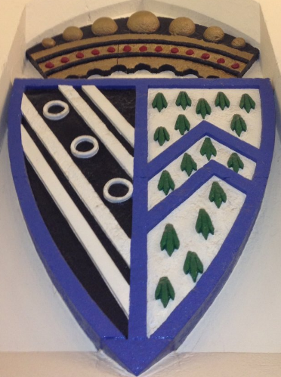
Mrs N Hayden-Craggs (Clerk) 01262 229512
07974284197
njhayden@hotmail.co.uk
2 St Johns Avenue www.huttonbuscelparishcouncil.org.uk
Bridlington
East Yorkshire
Parish Council
YO16 4NG
01262 229512

To all members of the Parish Council, County and Borough Councillors and Local Press.

13TH April 2017

Dear Councillor,

YOU ARE HEREBY SUMMONED to the ORDINARY COUNCIL MEETING of HUTTON BUSCEL
PARISH COUNCIL to be held on FRIDAY NEXT, the 21st APRIL 2017 immediately following the Annual
Parish Assembly at the Village Hall, Hutton Buscel.

Yours faithfully,

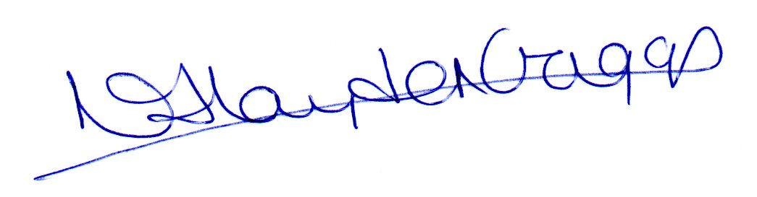
Mrs Nicola Hayden-Craggs
Clerk/RFO

AGENDA

- NOTICE OF MEETING – To confirm that notice has been given in accordance with
Schedule 12 Para 10(2) of the Local Government Act, 1972.

- APOLOGIES
a) To note any apologies for absence.
b) If received, to note and accept the reason for absence as valid.

- DECLARATION OF INTEREST
To note any declarations of interest in any of the agenda items listed below.

- APPROVAL OF MINUTES
a) To approve the minutes of the following meeting(s):
Ordinary council meeting dated– Friday 3rd March- To be circulated.
b) To note any matters arising from the minutes (for information purposes only)

- PUBLIC FORUM
a) To allow members of the public to speak within the Council meeting (maximum 15 minutes)
c) To decide on what action the Council wish to take on any items raised within the Public Forum.

- POLICE REPORT – (To be circulated)

- REPORTS FROM COUNTY AND BOROUGH WARD COUNCILLORS
Including NYCC report emailed 3.4.17 previously circulated.

- FINANCES (To be circulated)
    - To approve any accounts for payment.
    - Bank reconciliation.
    - Bin license
    - Mr C Borgan re: additional grant funding
    - Expiration Notification for Office 365 Home
    - Wykeham Quarry 106 money / Projects

- BENCH ISSUE
    - Payment
    - Provision of steps – Mrs Jewitt
    - Future bench policy

- PLANNING APPLICATION
Re:Land adjacent to 87 Hutton Buscel, Main Street, Hutton Buscel
http://planning.northyorkmoors.org.uk/Northgate/PlanningExplorer/Generic/StdDetails.aspx?PT=Planning%20Applications%20On-Line&TYPE=PL/PlanningPK.xml&PARAM0=813123&XSLT=/Northgate/PlanningExplorer/SiteFiles/Skins/NorthYorkMoors/xslt/PL/PLDetails.xslt&FT=Planning%20Application%20Details&PUBLIC=Y&XMLSIDE=/Northgate/PlanningExplorer/SiteFiles/Skins/NorthYorkMoors/Menus/PL.xml&DAURI=PLANNING

- CONSULTATION ON THE DOG CONTROL PUBLIC SPACE PROTECTION ORDER

- STATUS OF MIDDLE LANE- See previous email.

- PINFOLD
To receive an update on the grant funding application.

- PHONE BOX
    - Working party - update

- RESIGNATION OF CLERK
- To receive the letter of resignation
- To approve the advertisement and closing date.

- TO RECEIVE ITEMS FOR THE NEXT AGENDA

- TO CONFIRM THE DATE OF THE NEXT MEETING
Friday 3RD March 2017 at 7.00pm

If any Councillor wishes to view any documentation on, or discuss any of the above items
prior to the meeting, please make a mutually convenient appointment with me.
If a member fails throughout six consecutive months to attend any meetings of the Council
or of its Committees of which he/she is a member, he/she ceases automatically to be a member
of the Council, unless they have a ‘statutory excuse’ or the failure to attend is due to a reason
approved by the Council. The period begins with the last meeting attended.

