Parish Clerk
Hutton Buscel
Dawn Naylor
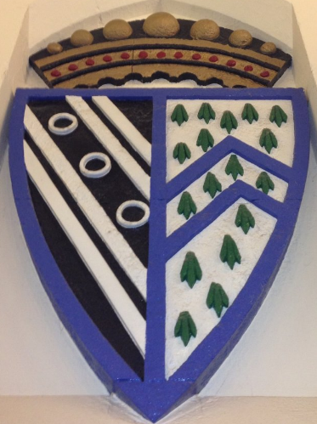
26 Ings Close
Staxton
YO12 4ST

Email: huttonbuscelpc1@btinternet.com
Telephone: 01944711139

Circulated to County and Borough Councillors and Public

26 February 2020

To all Members of Hutton Buscel Parish Council

Dear Councillor

YOU ARE HEREBY SUMMONED TO ATTEND an Ordinary Meeting of the Parish Council to be held on Monday 2 March 2020 at the Village Hall, Hutton Buscel commencing at 7.30pm.

Yours faithfully

Dawn Naylor
Parish Clerk

FILMING OF MEETINGS – A reminder to Members and members of the public that as of 6 August 2014 via the
Openness of Local Government Regulations it is possible that this meeting may be recorded by third parties.

NOTICE OF MEETING – Public Notice of the meeting has been given in accordance with Schedule 12, Para 10(2) of the Local Government Act 1972.

AGENDA

1. APOLOGIES
To receive any apologies.

2. DECLARATIONS OF INTEREST
Reminder to Members to disclose either a Pecuniary Interest or Other Interest in any item on the Agenda. Please note that the clerk cannot advise members on this. Members are personally responsible for declaring an interest. Members are respectfully advised to read the Code of Conduct (previously circulated) for information. Please also note that councillors are responsible for ensuring that their Registers of Interests are up to date (within 28 days of any changes).

3. MINUTES
To receive and if approved, to sign the following minutes:
- Ordinary Meeting – 3 February 2020

4. MATTERS ARISING
a) Min No 7/20- Drainage Grips
To receive a response from Richard Marr NYCC Highways regarding clearing out of drainage grips and to receive a drawing from a resident regarding a potential flooding solution.

b) Min No 29/20 – Wykeham Quarry Fund
To receive an update on the above funding bid.

5. PUBLIC COMMENTS
15 minutes will be allotted to receive comments from members of the public present at the meeting appertaining to parish council business on this agenda.

6. POLICE REPORT
To receive a report from the police.

7. NORTH YORKSHIRE COUNTY COUNCIL/SCARBOROUGH BOROUGH COUNCIL/NYMNPA
To receive any reports from Borough/County/NYMNPA Councillors regarding Hutton Buscel.

8. SEAMER HORSE FAIR – BLUE LINE
To request that the blue line is in place before the above horse fair.

9. PASSENGER TRANSPORT
To discuss the above document and make a decision whether to fill in the document – see email previously sent or check the following link: https://www.gov.uk/government/publications/a-better-deal-for-bus-users

10. PLANNING APPLICATIONS
To make relevant comments on the following planning applications:
- NYM/2020/0089/FL
Application for installation of replacement windows at The Granary, Great Moor Road.

- NYM/2019/0859//LB
Application for listed building consent for internal alterations at Baynigg, Main Street.

- NYM/2020/0065/FL
Application for construction of single storey rear extension at 8 Pickering Road.

11. VE DAY
To discuss if/how the parish council wish to commemorate the above (deferred from the last meeting).

12. OUTSIDE ORGANISATIONS
To receive reports from Councillors on outside bodies or any meetings held on behalf of the parish council.

13. FINANCE
a) To sign cheques as per schedule submitted at meeting.
b) To receive the bank statement.

14. ANY ITEMS FOR THE NEXT MEETING
To receive items to be placed on the next agenda.

15. DATE OF THE NEXT MEETING – 6 April 2020 (Ordinary & Annual Parish)

