Parish Clerk
Hutton Buscel
Dawn Naylor
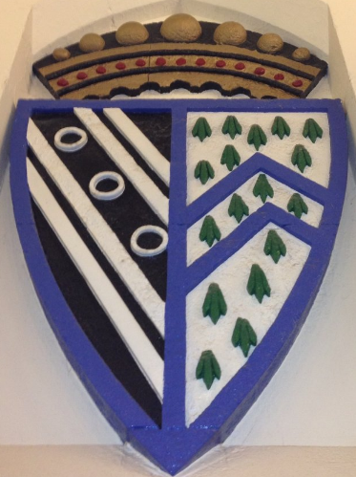
26 Ings Close
Staxton
YO12 4ST

Email: huttonbuscelpc1@btinternet.com
Telephone: 01944711139

Circulated to County and Borough Councillors and Public

2 February 2022

To all Members of Hutton Buscel Parish Council

Dear Councillor

YOU ARE HEREBY SUMMONED TO ATTEND an Ordinary Meeting of the Parish Council to be held on Monday 7 February 2022 at the Village Hall commencing at 7.30pm.

Yours faithfully

Dawn Naylor
Parish Clerk

AGENDA

1. APOLOGIES
To receive any apologies.

2. CO-OPTION
To agree the co-option of a resident onto the parish council.

3. DECLARATIONS OF INTEREST
Reminder to Members to disclose either a Pecuniary Interest or Other Interest in any item on the Agenda. Please note that the clerk cannot advise members on this. Members are personally responsible for declaring an interest. Members are respectfully advised to read the Code of Conduct (previously circulated) for information. Please also note that councillors are responsible for ensuring that their Registers of Interests are up to date (within 28 days of any changes).

4. MINUTES
To receive and if approved, to sign the following minutes:
- 1 November 2022

5. MATTERS ARISING FROM PREVIOUS MINUTES
Bus Service - to receive an update from the clerk.

6. PUBLIC COMMENTS
15 minutes will be allotted to receive comments from members of the public present at the meeting appertaining to parish council business on this agenda.

7. POLICE REPORT
To receive the above report.

8. NORTH YORKSHIRE COUNTY COUNCIL/SCARBOROUGH BOROUGH COUNCIL/NYMNPA
To receive any reports from Borough/County/NYMNPA Councillors regarding Hutton Buscel.

9. NEWSLETTER
To discuss the size of the current newsletter and make a decision thereon.

10. COUNCILLOR TRAINING
To discuss training for parish councillors.

11. TREES – VICARS WALK
To discuss the cutting of the Yew trees and make a decision thereon.

12. VILLAGE CUP
To agree to the recipient of the village cup.

13. QUEEN’S PLATINUM JUBILEE
To discuss the above event.

14. FINANCE
a) To receive the accounts passed for payment.
b) To receive the bank reconciliation.

15. REPORTS FROM OUTSIDE ORGANISATIONS
To receive reports on any meetings/training attended since the last meeting.

16. ANY ITEMS FOR THE NEXT MEETING
To receive items to be placed on the next agenda.

17. DATE OF NEXT MEETING – 7 March 2022

